Low Level Design

**NBA DRAFT PICK**

**Data Analysis**

|  |  |
| --- | --- |
| **Written By** | Sumit Mohod |
| **Document Version** | 0.1 |
| **Last Revised Date** |  |

# DOCUMENT CONTROL

**Change Record:**

|  |  |  |  |  |  |  |
| --- | --- | --- | --- | --- | --- | --- |
| **VERSION** | **DATE** |  | **AUTHOR** |  | **COMMENTS** |  |
| 0.1 | 20-03-2023 |  | Sumit Mohod |  | Prepared Low Level Document for NBA Draft Pick Data Analysis |  |
|  |  |  |  |  |  |  |
|  |  |  |  |  |  |  |
|  |  |  |  |  |  |  |

**Reviews:**

|  |  |  |  |  |  |  |  |  |
| --- | --- | --- | --- | --- | --- | --- | --- | --- |
| **VERSION** | **DATE** |  | **REVIEWER** |  | **COMMENTS** | | |  |
|  |  |  |  |  |  | | |  |
| **Approval Status:** | |  |  |  |  | | |  |
| **VERSION** | **REVIEW DATE** |  | **REVIEWED BY** |  |  | **APPROVED BY** |  | **COMMENTS** |
|  |  |  | |  | |  |  | |

# Contents

## 1. Introduction………………………………………………………………………………………………………… 04

**1.1 What is Low-Level Design Document? …………………………………………………….. 04**

**1.2 Scope ……………………………………………………………………………………………………... 04**

## 2. Architecture ………………………………………………………………………………………………………. 05

## 3. Architecture Description ……………………………………………………………………………………. 08

**3.1 Data Description ……………………………………………………………………………………… 08**

**3.2 Data Cleaning…………………………………………………………………………………………….09**

**3.3 Data Importing …………………………………………………………………........................ 09**

**3.4 Data Transformation in Power BI………………………………………........................ 10**

**3.5 Deployment …………………………………………………………………………………………….. 11**

**4. Unit Test Cases ……………………………………………………………………………………………..……. 12**

# 1. Introduction

**1.1 What is Low-Level design document?**

The goal of the LDD or Low-level design document (LLDD) is to give the internal logic design of the actual program code for the House Price Prediction dashboard. LDD describes the class diagrams with the methods and relations between classes and programs specs. It describes the modules so that the programmer can directly code the program from the document.

## 1.2 Scope

Low-level design (LLD) is a component-level design process that follows a step-by-step refinement process. The process can be used for designing data structures, required software architecture, source code and ultimately, performance algorithms. Overall, the data organization may be defined during requirement analysis and then refined during data design work.

# 2. Architecture

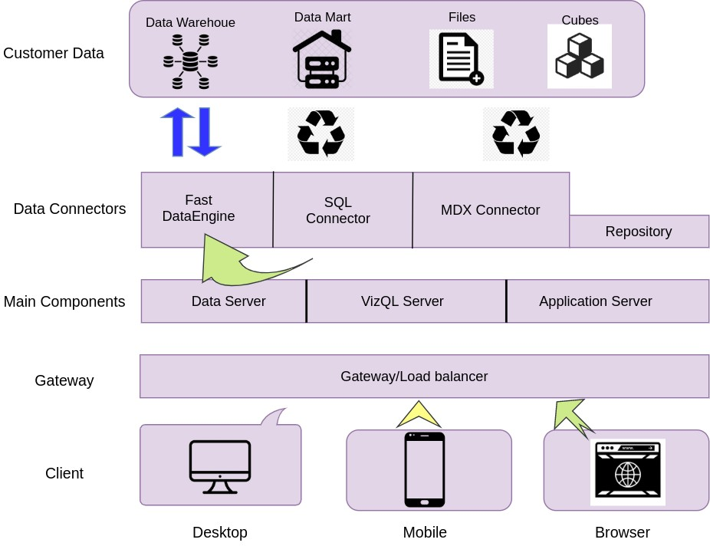

# Power BI Architecture

|  |
| --- |
| Power Bi has a highly scalable architecture that serves mobile clients, web clients and desktop- installed software. Power BI architecture supports fast and flexible report and dashboard creation to drive business insights. The following diagram shows Power BI’s architecture:      Power BI architecture is a service built on top of Azure. There are multiple data sources that Power BI can connect to. Power BI Desktop allows you to create reports and data visualizations on the dataset. Power BI gateway is connected to on-premise data sources to get continuous data for reporting and analytics. |

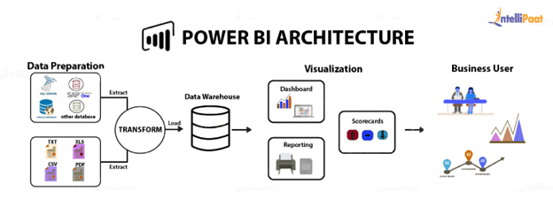

## 1. Gateway/Load Balancer

It acts as an Entry gate to the Power BI Server and also balances the load to the Server if multiple Processes are configured.

## 2. Application Server

Application Server processes handle browsing and permissions for the Power BI Server web and mobile interfaces. When a user opens a view in a client device, that user starts a session on Power Bi Server. This means that an Application Server thread starts and checks the permissions for that user and that view.

# 3. Architecture Description

## 3.1 Data Description

The Dataset contains NBA DRAFT PICK

1. Player : Player Name .
2. Year : which Year Player Pick .
3. Draft_Pick : how many times Player pick .
4. Height (No Shoes) : Player Height without Shoes.
5. Height (With Shoes) : Player Height With Shoes .
6. Wingspan : Player arm length from fingertip to fingertip .
7. Standing Reach : Player stand reach .
8. Vertical (Max) : measure player vertical jump .
9. Vertical (Max reach ) : measure player max vertical jump .
10. Vertical (No step) :
11. Vertical (No Step reach) :
12. Weight : player Weight .
13. Body Fat : Player Body Fat Level.
14. Hand (Length) : Measure Player Hand Length .
15. Hand (width) : Measure Player Hand Width .
16. Bench :
17. Agility : Agility of Player.
18. Sprint : Sprint of Player.

## 3.2. Data Cleaning

Data Cleaning is crucial stage before we start creating visuals. The dataset given some time has impurities such as missing values or incorrect data types. Data cleaning can be performed in Python using Pandas library to remove missing values and make dataset ready for building visuals.

## 3.3. Data Importing

In Power BI, we have options to connect to our dataset via various options such as SQL Server, MySQL, Excel, CSV and so on. We have our clean data in CSV file. We will import it in Power BI with import data option and start working with it.

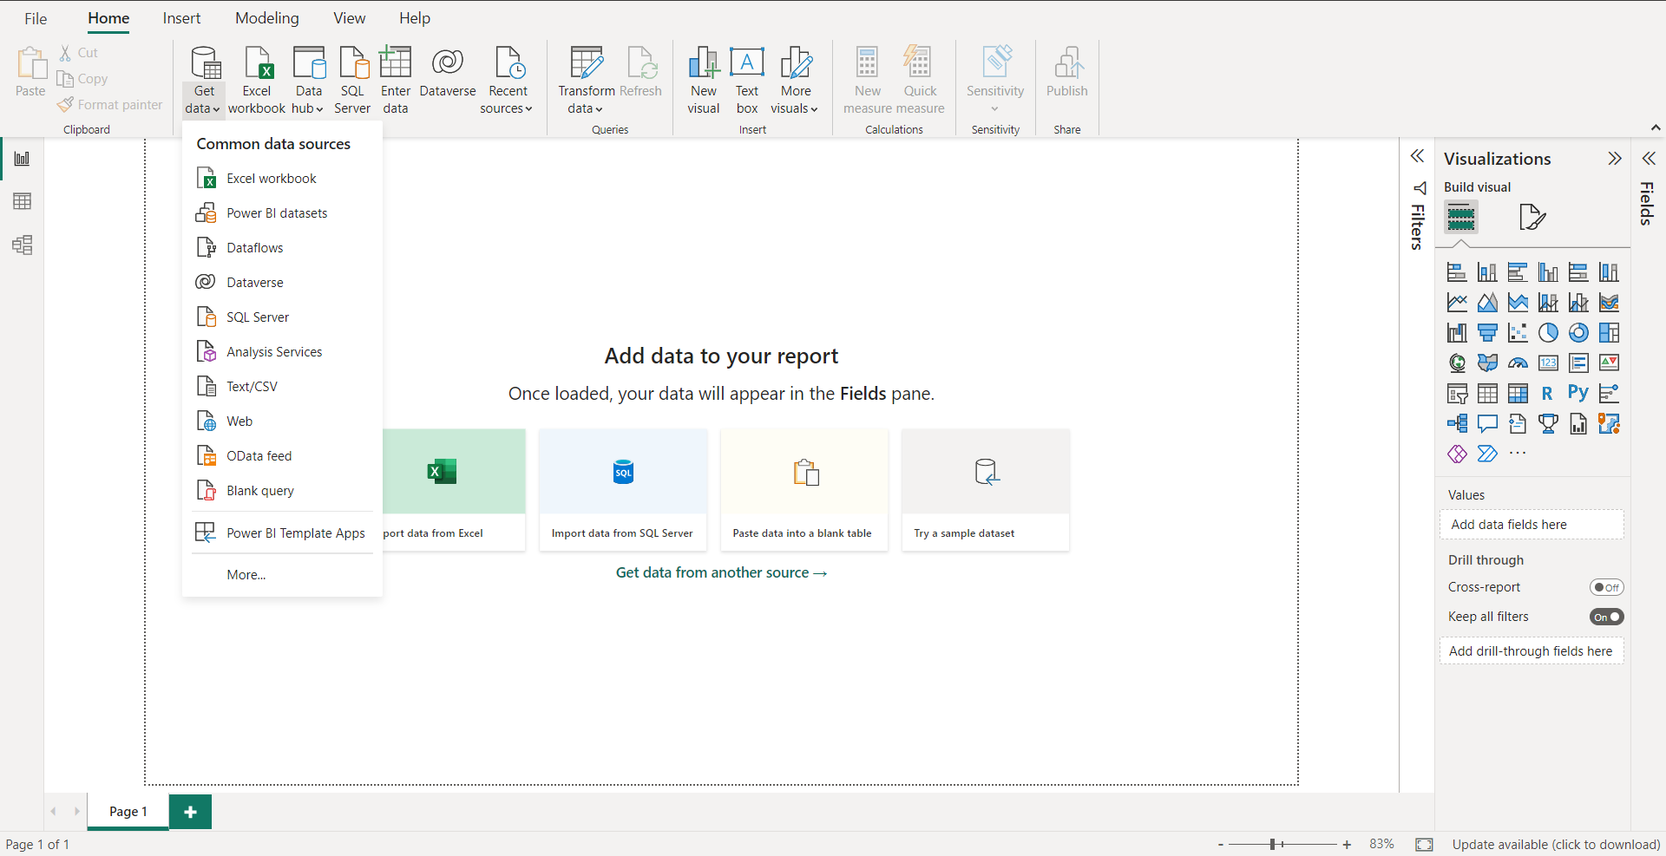

## 3.4 Data Transformation in Power BI

Once the data is imported in Power BI, we do ‘transform data’ i.e. using Power Query Editor to perform certain operation on the data. Ensuring correct data types, removing errors in data, creating custom/conditional columns are some fundamental task performed in Power Query.

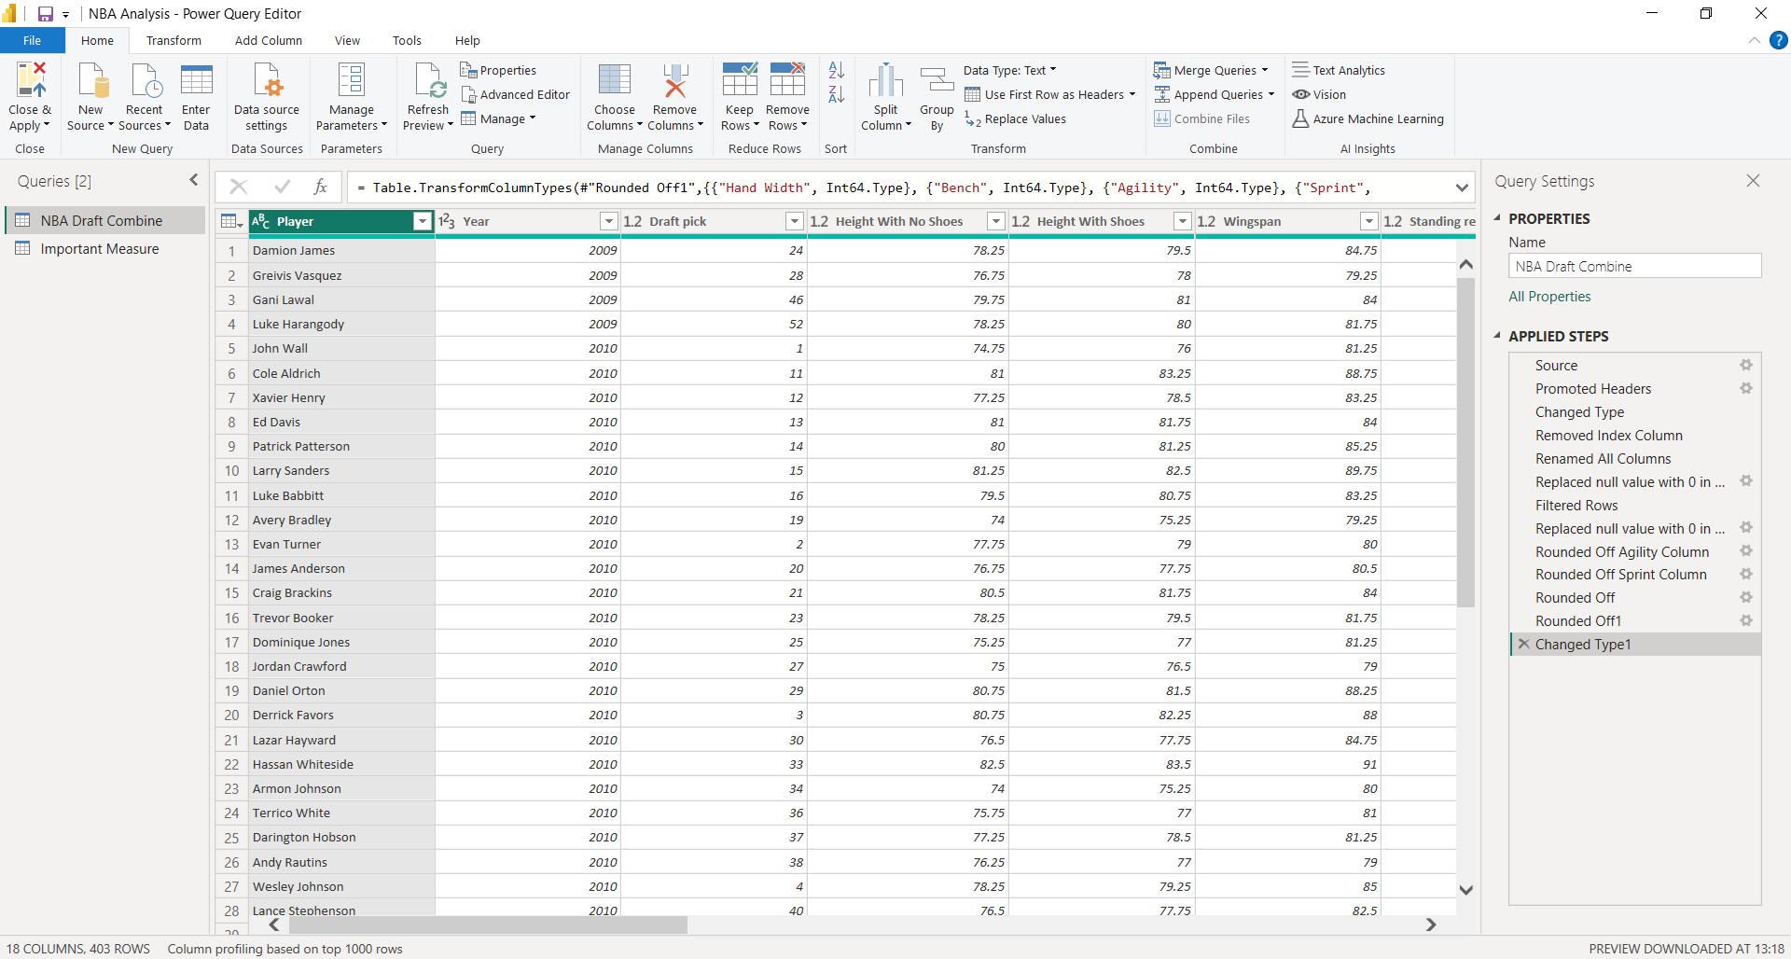

## 3.5 Deployment

In Power BI, you can directly publish the report online to your workstation. If you do not have the work email-id then you can save the file in ‘.pbix’ version. This helps another viewer see your work and understand the story or insights you are communicating.

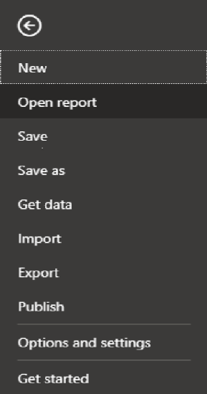

# 4. Unit Test Cases

|  |  |
| --- | --- |
| **TEST CASE DESCRIPTION** | **EXPECTED RESULTS** |
| Player Slicer | When clicked on the slicer, a dropdown should occur which has various players name. Selected particular player, shows result for that player. |
| Year Slicer | When clicked on the slicer, a dropdown should occur which shows list of years. Selected particular year shows result for that year. |
| Draft Picks by Player | This visual shows Total Draft Picks by Player. This is descending order i.e. Most draft picks Player at top. This visual shows overall performance of player by draft picks. |
| Top 5 Players by Draft Picks | This visual shows, top 5 player according to Draft Picks. |
| Top 5 Players by Vertical Max Reach | This visual shows, top 5 player according to Vertical Max Reach i.e. top 5 player high jump wise. |
| Top 5 Players by Wingspan | This visual shows, top 5 player according to wingspan. |
| Relationship between Player and Agility & Sprint | This visual shows a line chart displaying relation between Player and Agility & Sprint. This visual shows us how player is agility and sprint wise. |